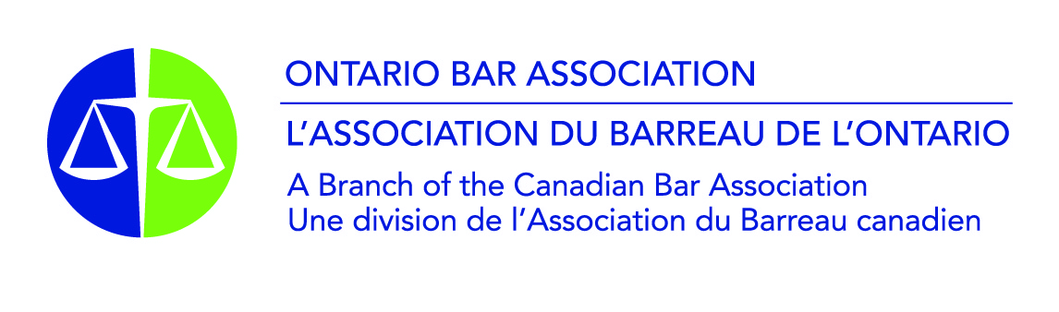
OBA/OJEN Competitive Mock Trials
Marking Scheme
_____________________________________________________________________________________
How the judges will score your team:

All the categories are scored out of 10. The descriptions on the marking scheme represent a standard corresponding to 7 to 8 out of 10. Judges use that standard as the starting point for scoring in each category. The judge asks themself if the performance in the category…

- Meet the standard described? = 7 to 8/10. If the performance was mostly to the standard, but a bit lacking on one or two points, that would be a 7. If it was very solidly to the standard, that would be an 8.
- Exceed the standard? = 8.5 to 10/10: If the judges is satisfied that the performance met the standard and went beyond it, they score 8.5 and higher. But, to give a score of 10, the judge must be convinced that there was essentially nothing else that the student/team could have done better in that category.
- Fall below the standard? = 5 to 6.5/10: If the performance was below the standard on more points than it met the standard, then the judge will score 6.5 or 6, down to 5.5 or 5 for performances what were well off the mark.
- Fall well below the standard? = 0 to 4.5/10: The scale is out of 10, just as marks in school are out of 100%. So, this is a “fail”. Marks in this range are for where there are major problems with a performance. To score in this range, performances will have been very disorganized and difficult to follow, have really failed to engage with the facts and relevant law of the case, or made crucial errors. There may also have been issues of discourtesy, rudeness, etc.

Score sheet: Most (but not all) OOCMT tournaments will provide copies of score sheets. If there is a panel of judges, they have the choice whether to fill out separate score sheets, or fill out a single sheet for the panel.

Judicial remarks sheet: This was created so that judges can give some written feedback on the very key points that made a difference to the round, to provide a bit more context for the scores given. It is anticipated that filling in the remarks sheet will help judges focus their oral feedback as well. Depending on time and personal preference, judges may choose not to fill out the remarks sheet.

OBA/OJEN Competitive Mock Trials
Score Sheet
Round # ________ |  | Courtroom # ________
Crown Team: |  | Defence Team:
Counsel: |  | Counsel:
Opening Statement | /10 | Opening Statement | /10
Direct Examination of  1st Crown Witness | /10 | Cross Examination of  1st Crown Witness | /10
Direct Examination of  2nd Crown Witness | /10 | Cross-Examination of  2nd Crown Witness | /10
Cross-Examination of  1st Defence Witness | /10 | Direct-Examination of  1st Defence Witness | /10
Cross-Examination of  2nd Defence Witness | /10 | Direct-Examination of  2nd Defence Witness | /10
Closing Arguments | /10 | Closing Arguments | /10
Subtotal: | /60 | Subtotal: | /60
Witnesses: |  | Witnesses:
1st Crown Witness  Direct Examination | /10 | 1st Defence Witness  Direct Examination | /10
1st Crown Witness  Cross-Examination | /10 | 1st Defence Witness  Cross-Examination | /10
2nd Crown Witness  Direct Examination | /10 | 2nd Defence Witness  Direct Examination | /10
2nd Crown Witness  Cross-Examination | /10 | 2nd Defence Witness  Cross-Examination | /10
Subtotal: | /40 | Subtotal: | /40
Overall Impression: |  | Overall Impression:
Knowledge of Law and Procedure | /10 | Knowledge of Law and Procedure | /10
Quality and Coherence of Case Theory | /10 | Quality and Coherence  of Case Theory | /10
Subtotal: | /20 | Subtotal: | /20
Grand Total: | /120 | Grand Total: | /120

OBA/OJEN Competitive Mock Trials – Judicial Remarks
ROUND: __________ ROOM: _________
VERDICT
Guilty | Not Guilty | Guilty of lesser offence: ___________________________
Key reasons for verdict:
PERFORMANCE & ARGUMENTS
Stronger aspects (maximum three points):
CROWN |  |  | DEFENCE
Weaker aspects (maximum three points):
CROWN |  |  | DEFENCE

