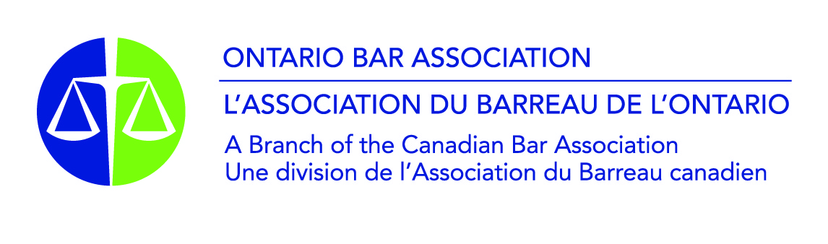
OBA/OJEN Competitive Mock Trials
Marking Scheme
_____________________________________________________________________________________
How the judges will score your team:

All the categories are scored out of 10. The descriptions on the marking scheme represent a standard corresponding to 7 to 8 out of 10. Judges use that standard as the starting point for scoring in each category. The judge asks themself if the performance in the category…

- Meet the standard described? = 7 to 8/10. If the performance was mostly to the standard, but a bit lacking on one or two points, that would be a 7. If it was very solidly to the standard, that would be an 8.
- Exceed the standard? = 8.5 to 10/10: If the judges is satisfied that the performance met the standard and went beyond it, they score 8.5 and higher. But, to give a score of 10, the judge must be convinced that there was essentially nothing else that the student/team could have done better in that category.
- Fall below the standard? = 5 to 6.5/10: If the performance was below the standard on more points than it met the standard, then the judge will score 6.5 or 6, down to 5.5 or 5 for performances what were well off the mark.
- Fall well below the standard? = 0 to 4.5/10: The scale is out of 10, just as marks in school are out of 100%. So, this is a “fail”. Marks in this range are for where there are major problems with a performance. To score in this range, performances will have been very disorganized and difficult to follow, have really failed to engage with the facts and relevant law of the case, or made crucial errors. There may also have been issues of discourtesy, rudeness, etc.

Score sheet: Most (but not all) OOCMT tournaments will provide copies of score sheets. If there is a panel of judges, they have the choice whether to fill out separate score sheets, or fill out a single sheet for the panel.

Judicial remarks sheet: This was created so that judges can give some written feedback on the very key points that made a difference to the round, to provide a bit more context for the scores given. It is anticipated that filling in the remarks sheet will help judges focus their oral feedback as well. Depending on time and personal preference, judges may choose not to fill out the remarks sheet.

 | Categories: | Performance Standard
 | Categories: | Well below standard: | Below standard: | Meets standard described below: | Exceeds standard: | Flawless:
 | Categories: | 1 4.5 | 5 6.5 | 7 8 | 8.5 9.5 | 10
COUNSEL | Opening Statements | · Presented clear and solid theory of case  · Allegations and elements of offence outlined with reasonable clarity  · Anticipated evidence well mapped-out  · Concise and without excessive argument
COUNSEL | Direct Examinations | · Questions were open-ended and not leading  · Questions were focused and brought out key information beneficial to own case  · Questions were connected to theory of case presented in opening statement  · Potential problems for own case were brought out and addressed
COUNSEL | Cross-Examinations | · Questions were focused, leading, and brought out key information for own case  · Identified and brought out key weaknesses and contradictions in other side’s case  · Adapted questioning in line with witness answers  · Effectively maintained control of witness
COUNSEL | Closing Arguments | · Organized, concise and well-reasoned summary, connected to theory of case  · Explained elements of offence(s), relevant legal tests and how burdens met/not met  · Natural presentation; adapted to actual evidence in round  · Left clear, comprehensible impression of case theory
COUNSEL | Counsel Performance  in General  (consider in scoring all above categories) | · Spoke clearly, with good eye contact and engagement with judges and/or witnesses  · Displayed level of comfort with environment and material; good use of notes but remained able to adapt submissions as needed  · Displayed professionalism, integrity and collegiality
WITNESSES | Direct Examinations | · Well-prepared; presented naturally and appeared credible  · Testimony brought out key points for own case and effectively dealt with any weak points or problems of own case
WITNESSES | Cross-Examinations | · Well-prepared; presented naturally and appeared credible  · Answered questions fairly and without unreasonable stalling or evasiveness  · Answers helped maintain own case as much as possible
WITNESSES | Witness Performance  in General  (consider in scoring both above categories) | · Well-developed character added authenticity, but did not distract from trial  · Testimony was consistent with sworn statement; was not “impeached”  · Displayed professionalism, integrity and collegiality
TEAM OVERALL | Knowledge of Law and Procedure | · Objections were relevant, timely, reasonable, and appropriately employed  · Counsel were well-versed and comfortable with procedure and courtroom environment  · Counsel knew and applied relevant legal tests to the facts of the case
TEAM OVERALL | Quality and Coherence of Case Theory and Presentation | · Team had a clear, well-reasoned theory of the case that was presented from the outset and remained clear and effectively presented throughout the trial  · Team displayed a cohesive effort; team members were clearly working together

OBA/OJEN Competitive Mock Trials
Score Sheet
Round # ________ |  | Courtroom # ________
Crown Team: |  | Defence Team:
Counsel: |  | Counsel:
Opening Statement | /10 | Opening Statement | /10
Direct Examination of  1st Crown Witness | /10 | Cross Examination of  1st Crown Witness | /10
Direct Examination of  2nd Crown Witness | /10 | Cross-Examination of  2nd Crown Witness | /10
Cross-Examination of  1st Defence Witness | /10 | Direct-Examination of  1st Defence Witness | /10
Cross-Examination of  2nd Defence Witness | /10 | Direct-Examination of  2nd Defence Witness | /10
Closing Arguments | /10 | Closing Arguments | /10
Subtotal: | /60 | Subtotal: | /60
Witnesses: |  | Witnesses:
1st Crown Witness  Direct Examination | /10 | 1st Defence Witness  Direct Examination | /10
1st Crown Witness  Cross-Examination | /10 | 1st Defence Witness  Cross-Examination | /10
2nd Crown Witness  Direct Examination | /10 | 2nd Defence Witness  Direct Examination | /10
2nd Crown Witness  Cross-Examination | /10 | 2nd Defence Witness  Cross-Examination | /10
Subtotal: | /40 | Subtotal: | /40
Overall Impression: |  | Overall Impression:
Knowledge of Law and Procedure | /10 | Knowledge of Law and Procedure | /10
Quality and Coherence of Case Theory | /10 | Quality and Coherence  of Case Theory | /10
Subtotal: | /20 | Subtotal: | /20
Grand Total: | /120 | Grand Total: | /120

OBA/OJEN Competitive Mock Trials – Judicial Remarks
ROUND: __________ ROOM: _________
VERDICT
Guilty | Not Guilty | Guilty of lesser offence: ___________________________
Key reasons for verdict:
PERFORMANCE & ARGUMENTS
Stronger aspects (maximum three points):
CROWN |  |  | DEFENCE
Weaker aspects (maximum three points):
CROWN |  |  | DEFENCE

