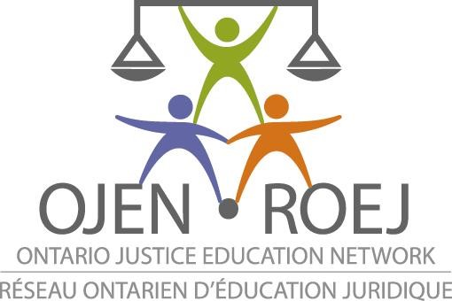

MUST BE COMPLETED IN FULL AND RETURNED AT TIME OF REGISTRATION

Braiding Diversity into Justice:
The goal of the “Braiding Diversity into Justice” event is to connect young women, who are marginalized and/or racialized, with members of the legal sector in order to motivate and empower them. We hope to inspire these young women of diverse backgrounds, and to help them feel confident in their ability to become successful legal/justice sector professionals.

Participant’s Information

Name: _________________________________________________ Grade: ____________________

Dietary Restrictions:
_________________________________________________________________________________

Email address:
_________________________________________________________________________________

School Name:
________________________________________________________________________________

Media Release

I consent to allow OJEN and Court Staff (collectively: Event Organizers) and/or media present at the Braiding Diversity into Justice program to reproduce, and/or publish, and/or broadcast the film and/or digital images, and/or video footage of me, or my child/ward taken during these events on _____.

I release and discharge these media outlets, Event Organizers and their officers and employees from any claims, obligations or liability of every kind, including those arising from use of these images and video footage.

This release shall be binding on my heirs, executors, administrators and assigns. I have read the above information and fully understand the contents. I hereby give the Event Organizers permission to use the aforementioned items and I authorize their use or reproduction by the Event Organizers or anyone authorized by them. I hereby also waive any rights of compensation or ownership thereto.

Print Name:

Signature Name:

180 Dundas Street West, Suite 505, Toronto, Ontario Canada M5G 1Z8 • PH: (416) 761 9963 • FAX: (416) 800 9034
• CHARITABLE # 65546 9134 RR0001

